Green Action Design

***“Green Action”*** *is an environmental volunteer* organization *dedicated to fostering sustainable practices and promoting environmental stewardship within local communities. We empower volunteers to take steps towards creating a greener and more sustainable future. Through a variety of educational programs, and community-driven events, the* organization *seeks to raise awareness about pressing environmental issues and inspire collective action.*

[Please access our web design here](https://www.figma.com/design/bbvZOhnobeO6H0mRWHgWNz/WDC-Project?t=RAeA0Y4Vm2QY58ZS-0)

# I. Research

## 1. Concept

- After discussing, we decided to create a website for an environmental volunteer organization. This is partly because of the current world’s natural situation, with global warming and pollution increasing all over the world. We hope this website will be somehow a message for everyone to raise awareness about environmental issues.

- The “Green Action” slogan acts as the website name and logo to emphasize the importance of taking action to preserve all beautiful green nature.

## 2. Design Choices

Below are the following choices for our design, following several meetings and discussions, and references online:

### **Colour Palette Choice:** With the idea of designing a website for an environmental volunteer organization, we chose a green color palette to highlight the organization's mission. And after searching the Green color palette on [ColorHunt](https://colorhunt.co/) for a while, we found this really nice palette:



Figure 1 - Green Action website color palette

To further see if this palette is a great fit for our website, we tested it on the [Realtime Colors](https://www.realtimecolors.com/) website, which passed all the standards for a standard website.

### **Font Choice:** After playing around the Realtime Colors website with different fonts, and with more research into [Google Fonts](https://fonts.google.com/), we came down to using the [Quicksand font](https://fonts.google.com/specimen/Quicksand?query=quicksand), which is thin and has round ends, which kind of resembles the aesthetics of nature. Below is the [final demo](https://www.realtimecolors.com/?colors=050315-f6faf0-8cbe47-9fdb97-70cd81&fonts=Quicksand-Quicksand) on Realtime Colors:

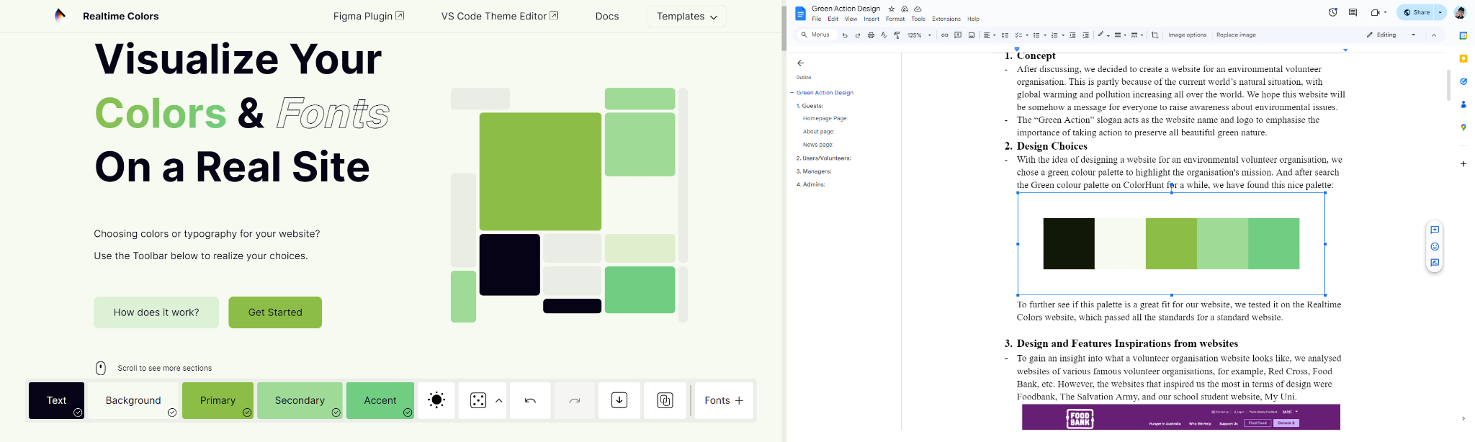

Figure 2 - Realtime Colors demo

### **Logo Choice:**

In contrast to most volunteer websites that use a white logo and a transparent background, we decided to use a logo with a green color and white background in order to make it stand out, attract users and emphasize the mission of the organization.

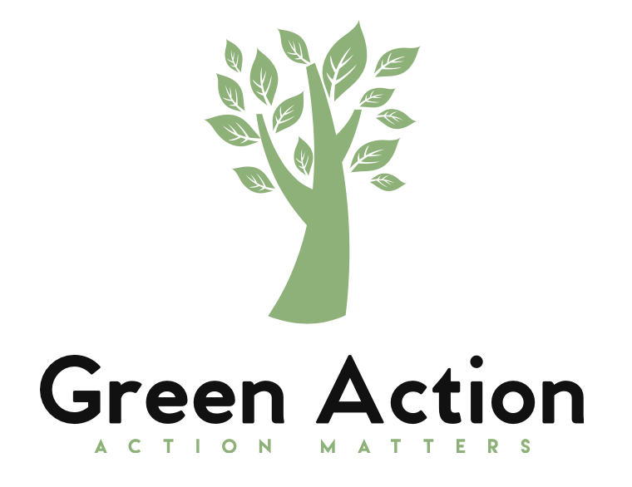

Figure 3 - Green Action logo

We also use an illustration of a tree with leaves attached to the branches to make the organization's symbol. It not only represents the organization's purpose of protecting the environment but is also a metaphor that emphasizes the value of the organization, which is ***solidarity*** and ***cooperation***. The leaves represent the efforts of each volunteer member, the more leaves, the healthier the tree will be and the farther its branches will reach, just like the more people gather and help, the greener the environment will become.

## 3. Design and Features Inspirations from websites

To gain an insight into what a volunteer organization website looks like, we analyzed websites of various famous volunteer organizations, for example, Red Cross, Food Bank, etc. However, the websites that inspired us the most in terms of design were Foodbank, The Salvation Army, and our school student website, MyUni.

### Navigation bar:

We found that the navigation bar of Foodbank looks minimal and it also has a convenient branch change dropdown button which helps reduce the cognitive and kinematic load.

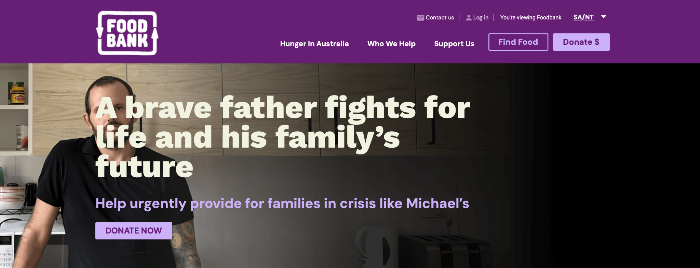

Figure 4 - Foodbank navigation bar

Inspired by it, we have designed a really simple navigation bar



Figure 5 - Green Action navigation bar

### Home page:

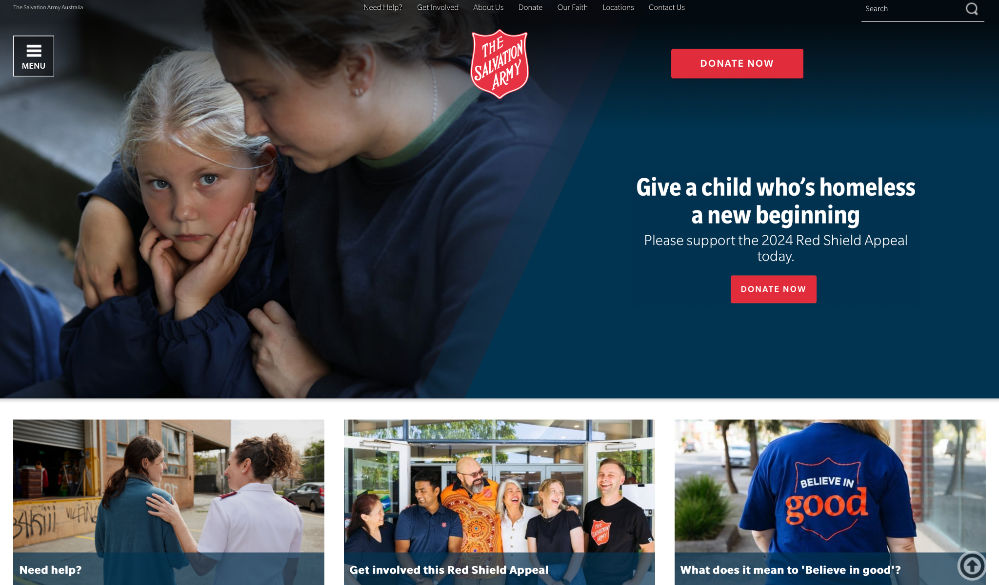

Figure 6 - The Salvation Army homepage

The Home page design of The Salvation Army is eye-catching with a large cover image combined with outstanding text, this helps emphasize the organization’s mission. This is our homepage inspired by it.

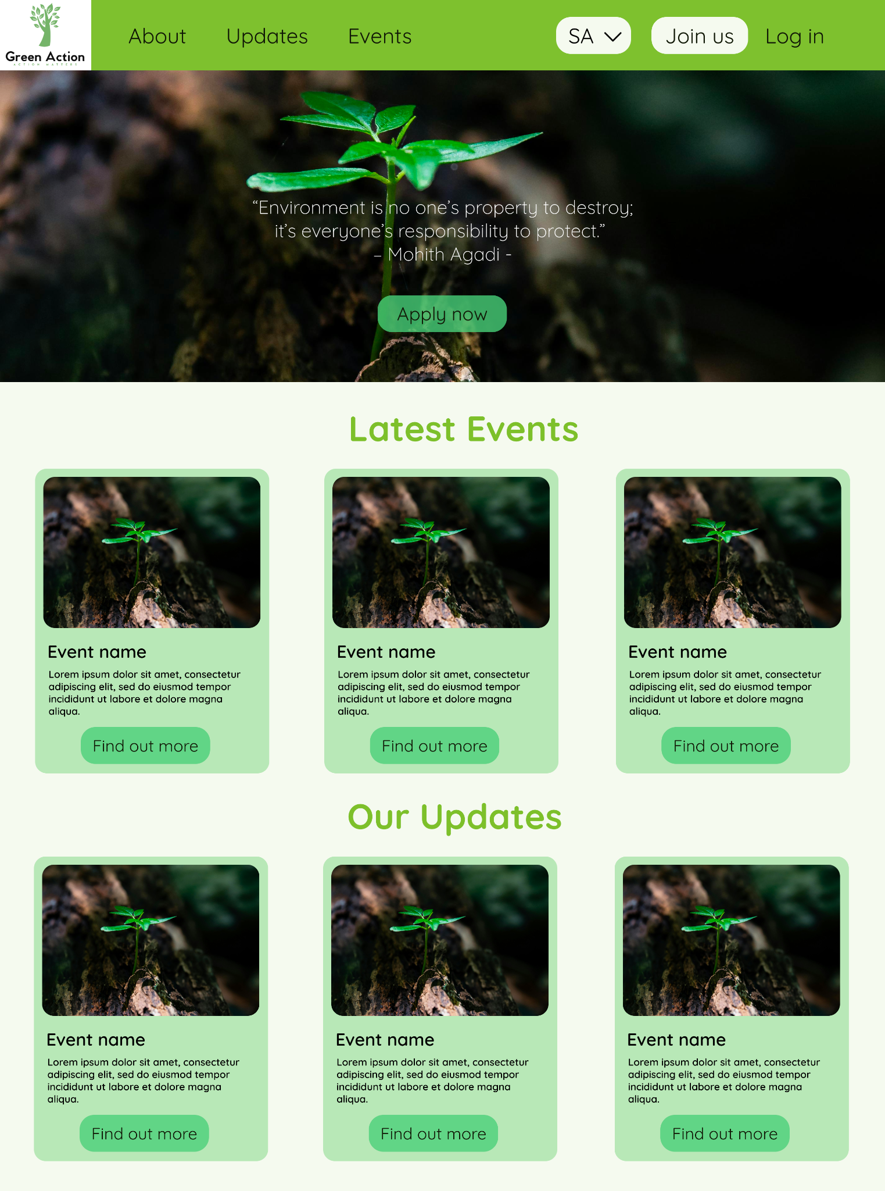

Figure 7 - Green Action homepage

### User - Dashboard page:

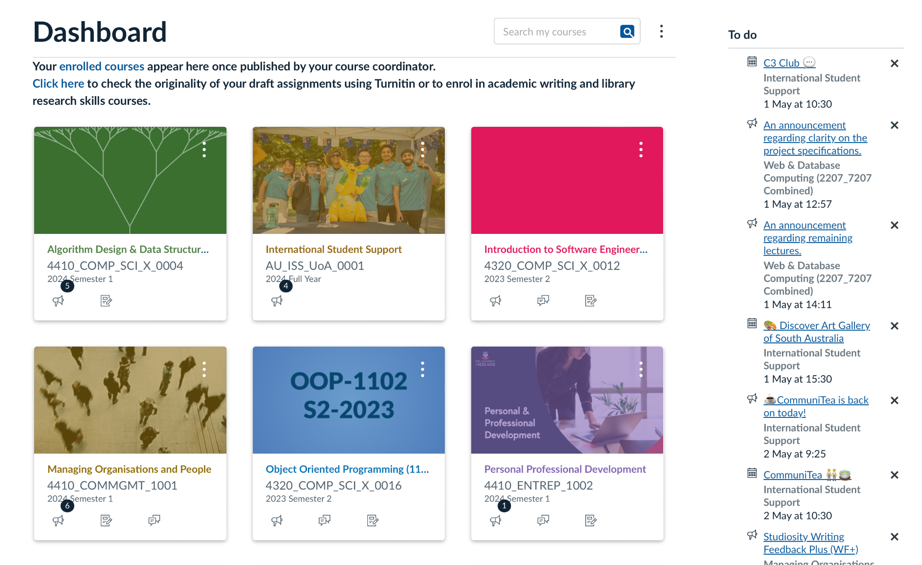

Figure 8 - My Uni Dashboard

The dashboard of My Uni has 2 columns, the left side is for enrolled courses and the right side is for to-do list and announcements. This is simple yet very convenient for the users as they can see and access all necessary information in the first place. We used this as a reference and then came up with our design.

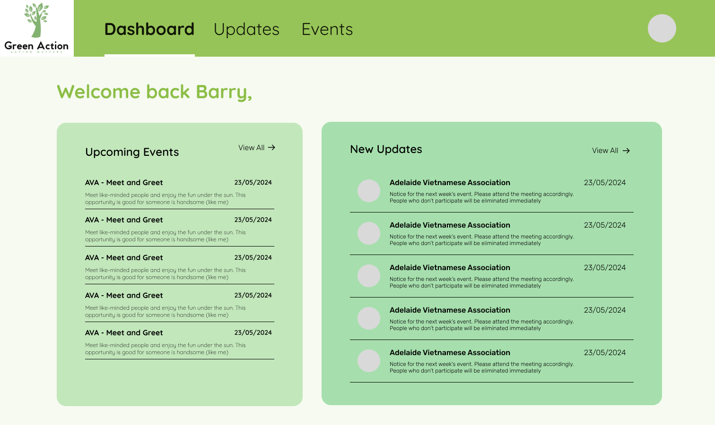

Figure 9 - Green Action User Dashboard

With this, users can see all recent updates and events immediately after logging in to the website, minimizing the kinematic load.

### User - Updates page:

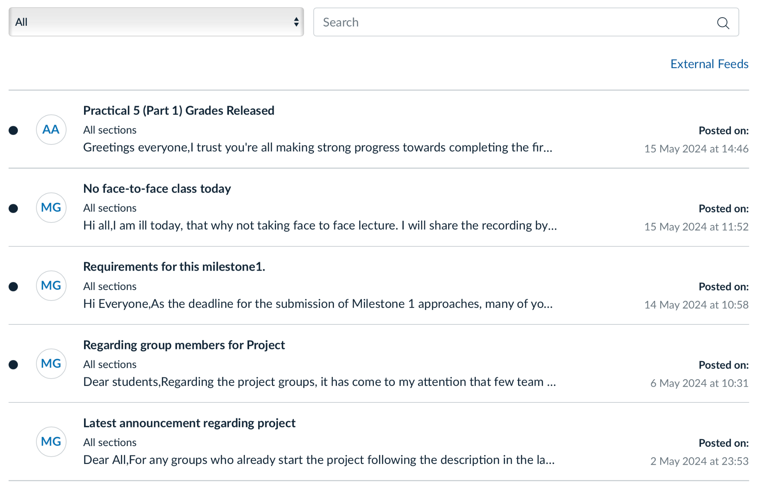

Figure 10 - My Uni course announcement page

My Uni announcement page is minimalist but provides enough information. It also has a filter and search function to allow users to find the announcement more efficiently. We were inspired by it to design the UI for our Updates page.

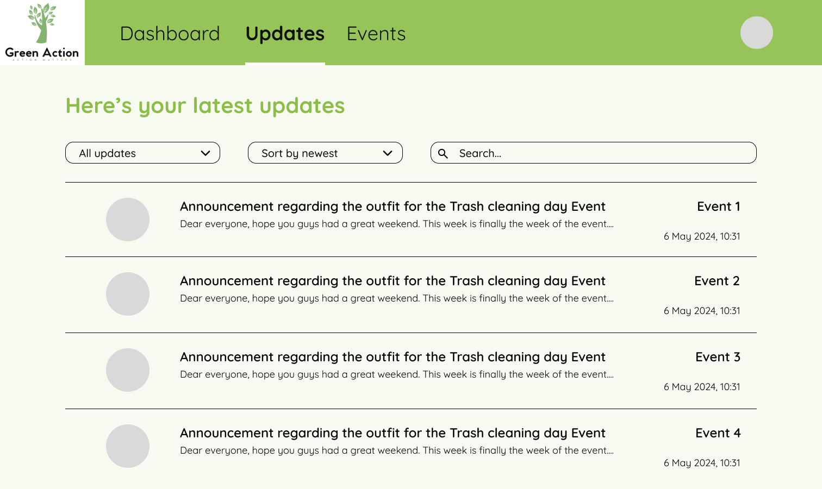

Figure 11 - Green Action User Updates page

# II. Design and Features

From the requirements, we have decided to have four distinct types of users, each with their respective UI. The user types are:

* Guests: People who are not members of the organization can visit the website homepage and learn more about the organization.
* Users/Volunteers: People who volunteer for the organization's events and participate in helping the organization.
* Managers: People who manage all the volunteers in a specific branch of the organization and help maintain good management within the organization.
* Admins: People who are administrators of the organization, managing and controlling everything on the website, including all users and branch information.

Below is a breakdown of each page design for each type of user:

## 1. Guests:

This page is where people who are not members of the organization can visit and obtain basic information about the organization such as their goals and the latest news about their updates and events.

### **Home page:**

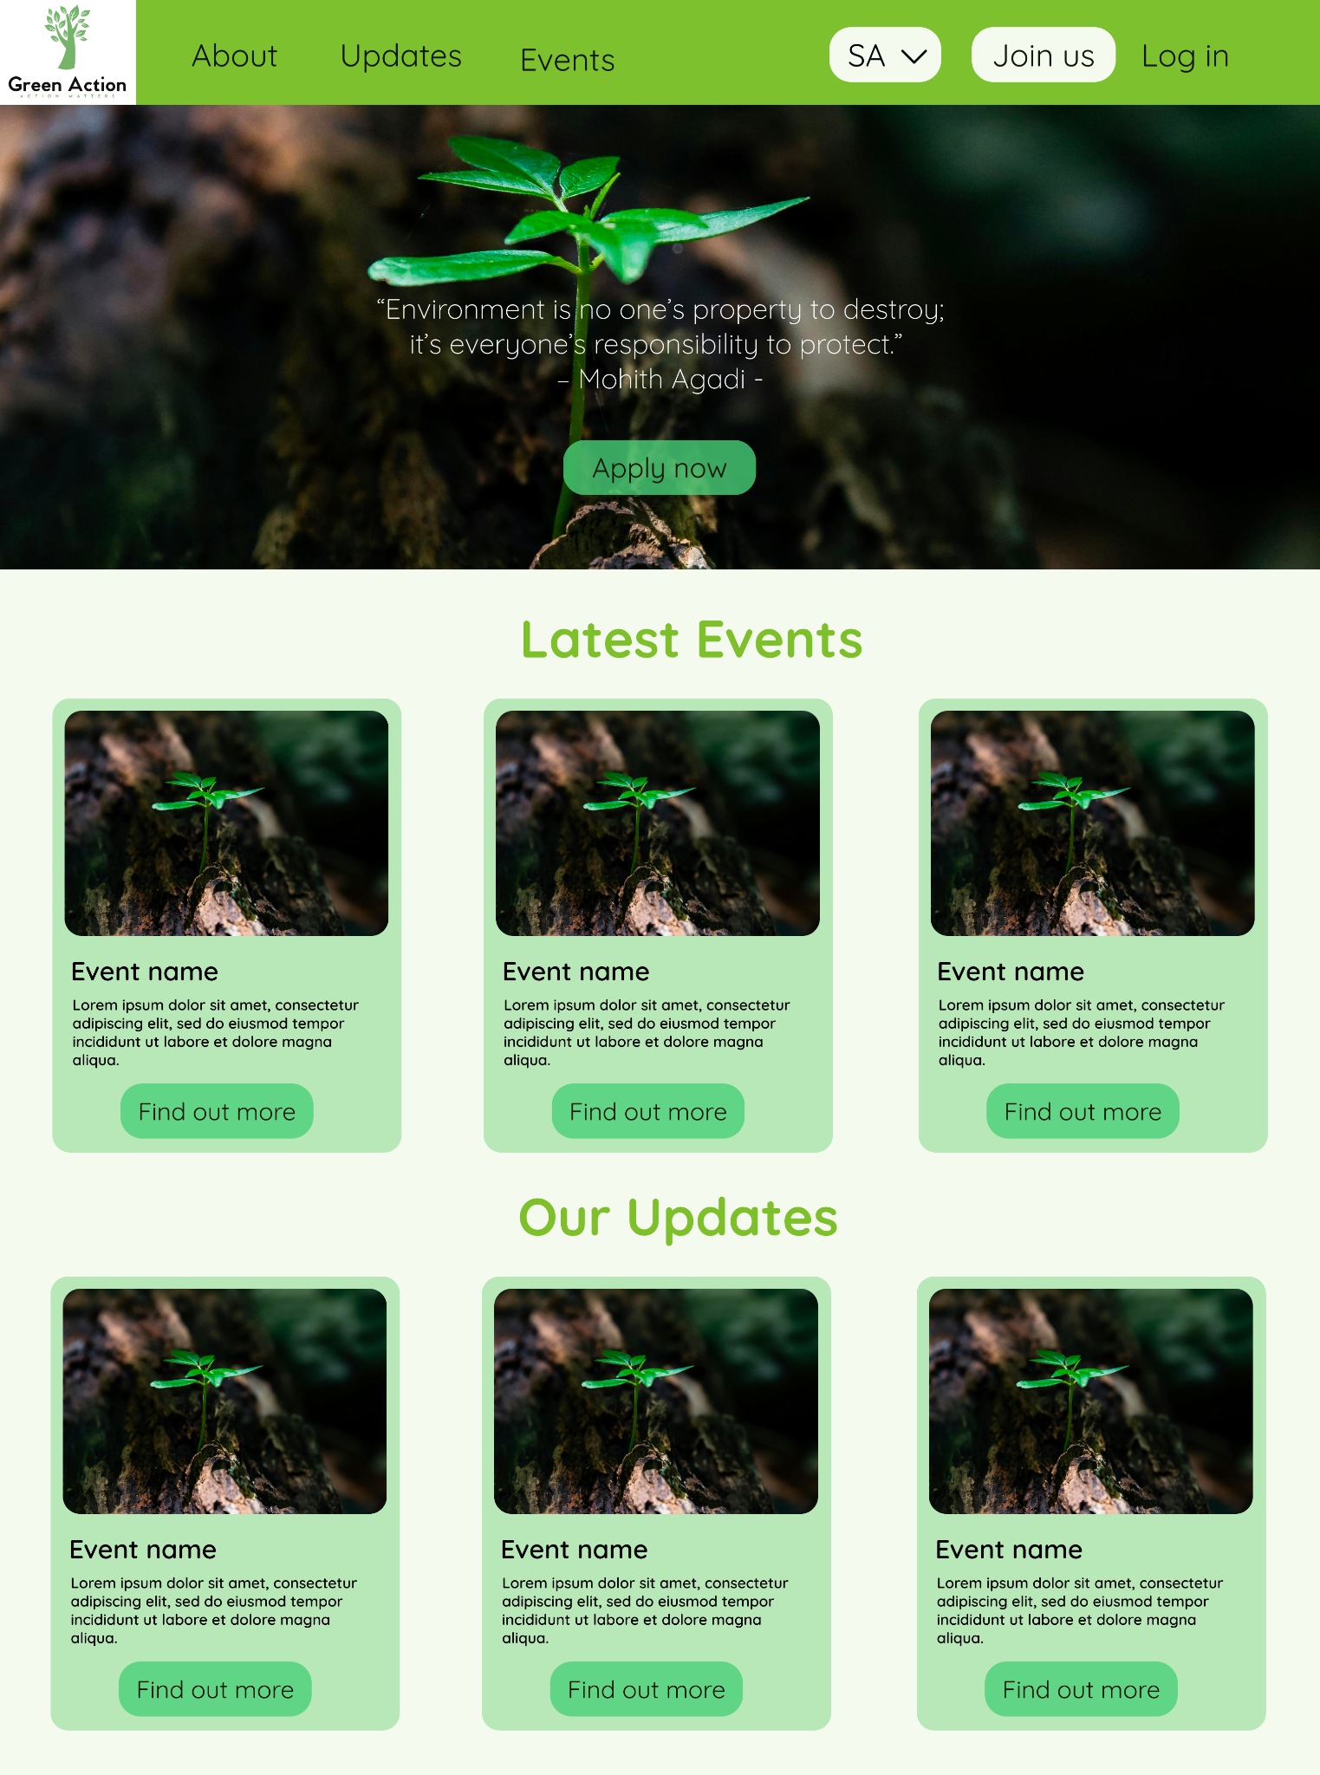

Figure 12 - Home page

The homepage is the first point of contact for guests, providing an inviting overview of the organization. This page is designed to inform visitors about the mission, goals, and recent activities of the organization. At the top, the header section includes the organization's logo, name, and a navigation menu with links to other pages such as About, Events, and Updates. The navigation menu is intuitive, making it easy for guests to find information.

A welcome message briefly introduces visitors to the organization's mission and goals. Below this, the page features a section showcasing the latest public updates and events. Each update or event includes a title, a brief description, and a "Read more" button that directs users to detailed pages.

Guests can easily switch between different branches of the organization using a dropdown button, which updates the displayed information accordingly. This feature minimizes cognitive load by making branch selection straightforward. Additionally, prominent "Apply now" and "Join us" buttons direct interested individuals to the application page, encouraging new volunteers to join. The footer section contains additional links, contact information, and social media icons to enhance connectivity.

### **About page:**

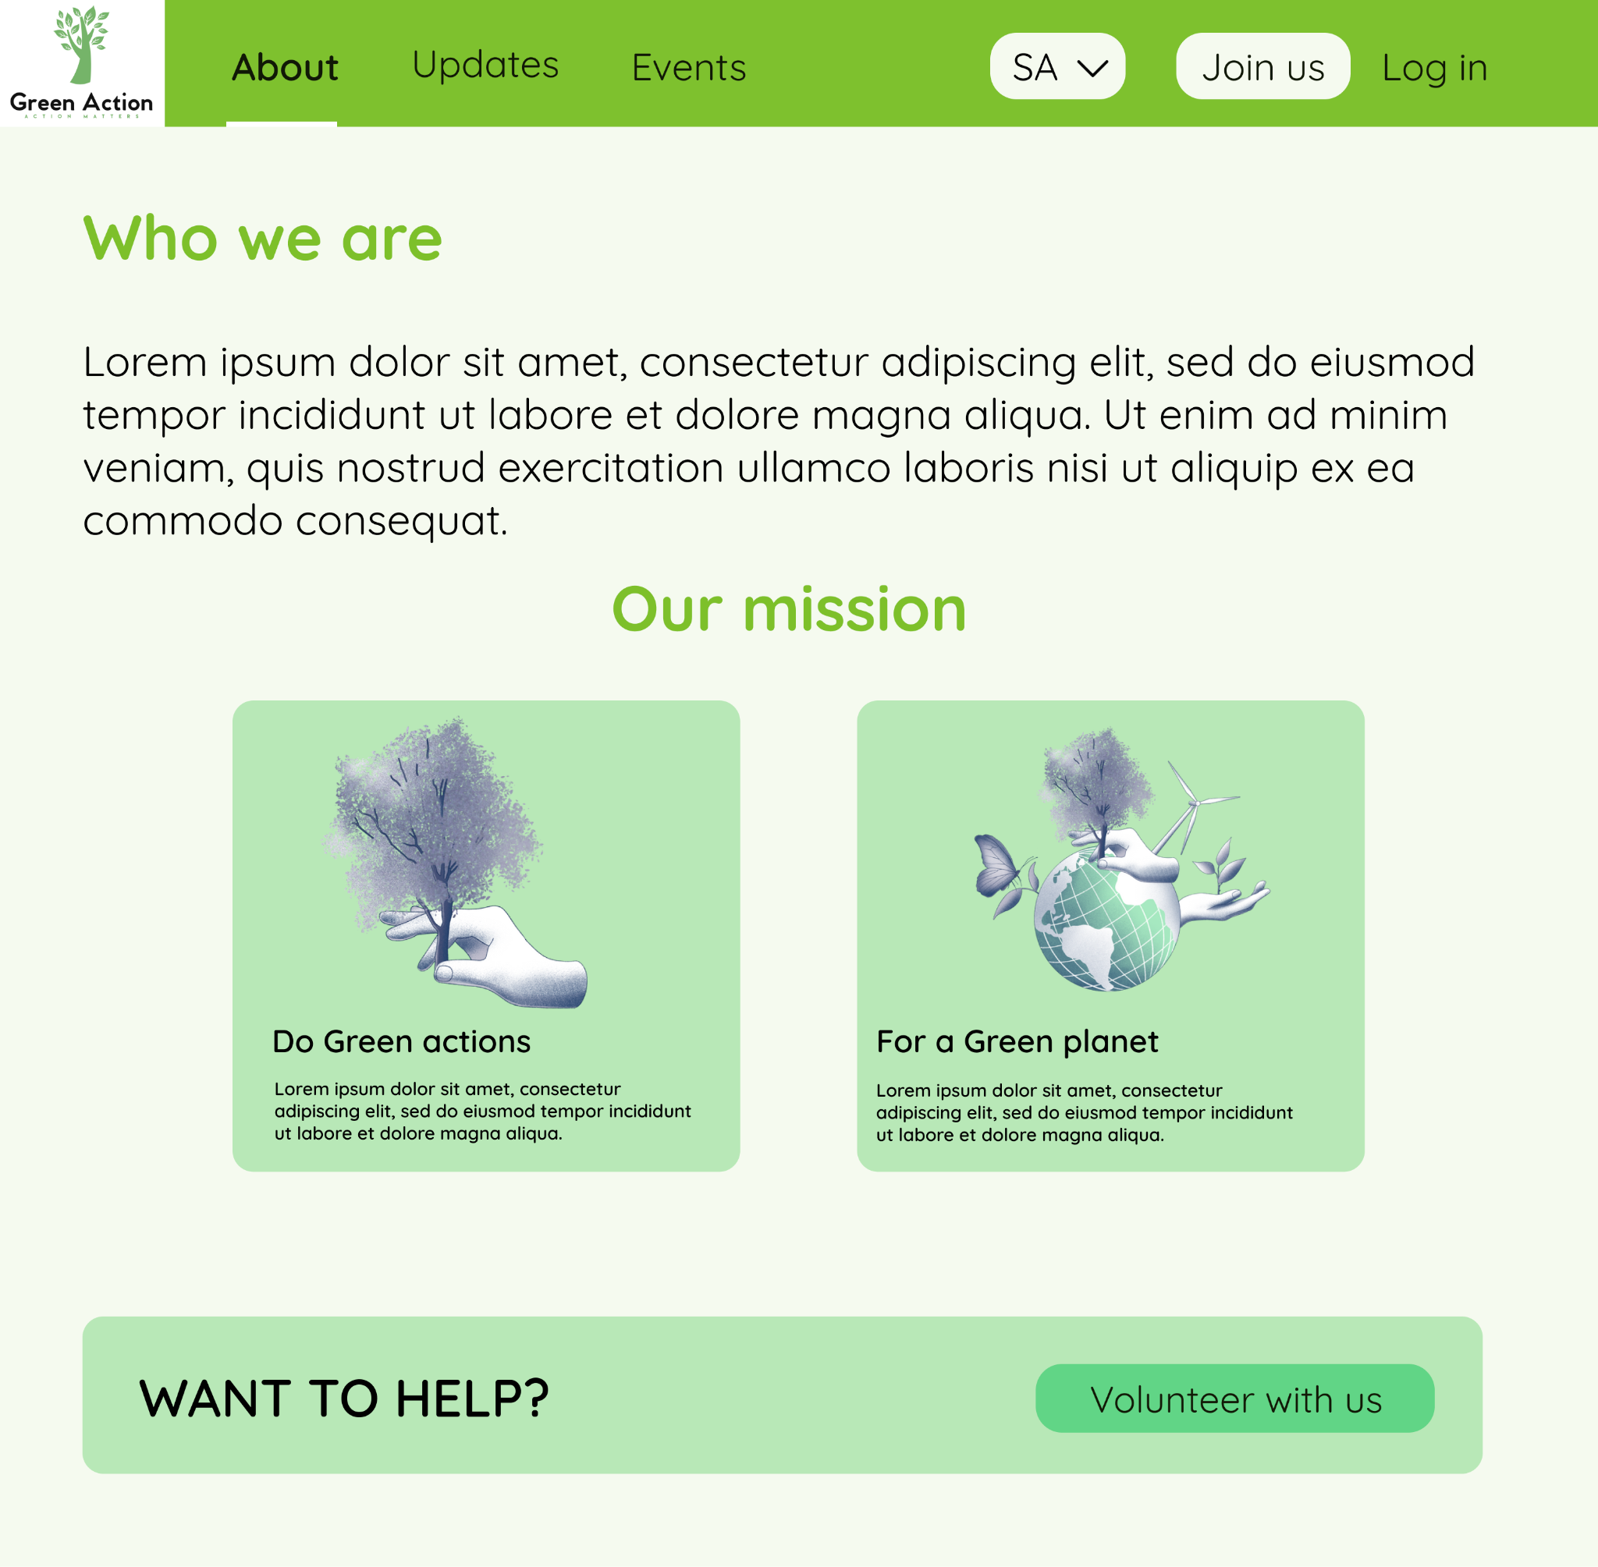

Figure 13 - Guest About page

The About page provides comprehensive information about the organization. This page is essential for building trust and credibility with potential volunteers and supporters. It includes a detailed section on the organization's history, covering its founding, key milestones, and significant achievements. Clear statements about the organization's mission and goals are provided, outlining the impact it aims to achieve.

Visitors can learn about the organization's ongoing and past activities, projects, and initiatives. A section dedicated to the core values and guiding principles explains what drives the organization's work. Profiles of key team members and their roles within the organization help personalize and humanize the group. Testimonials from volunteers, beneficiaries, and partners provide social proof of the organization's impact.

### **Events page:**

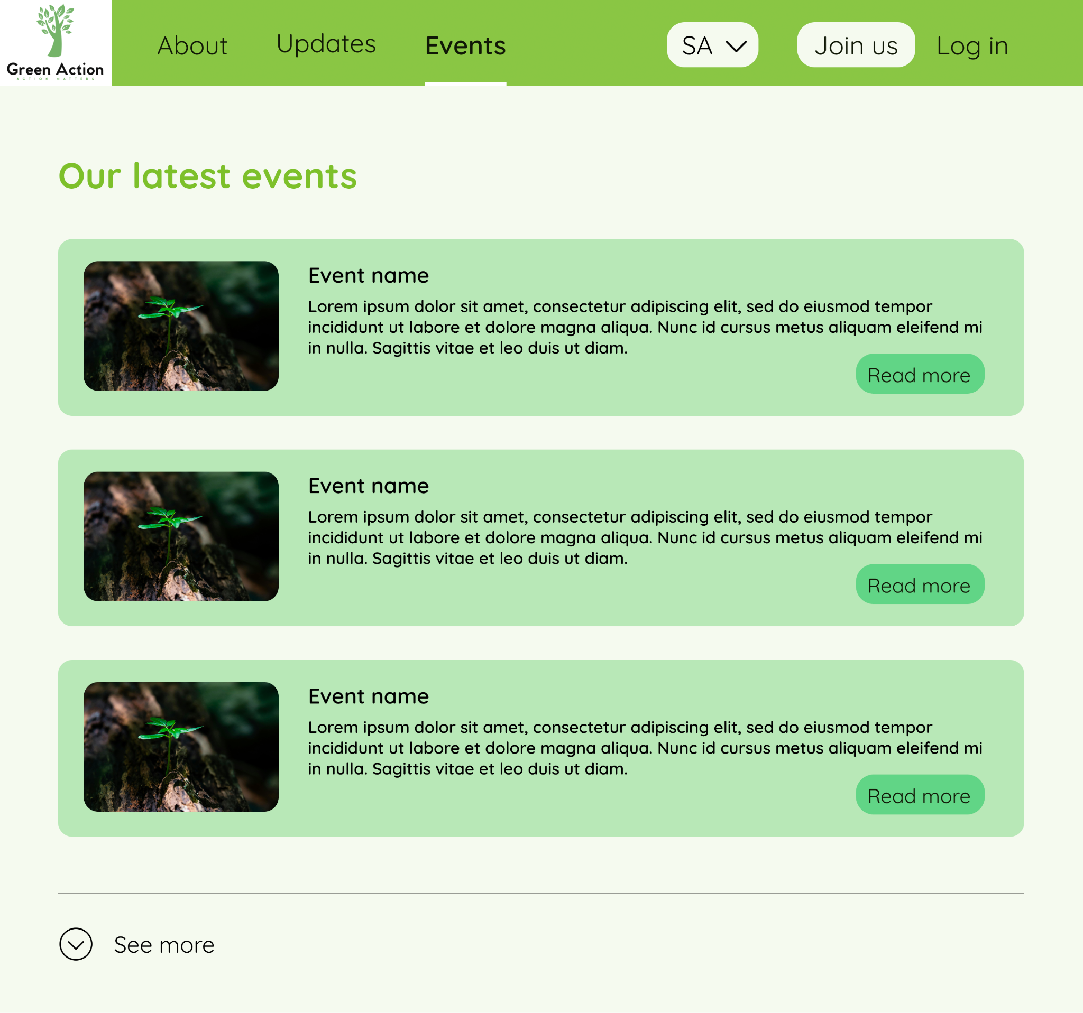

Figure 14 - Guest Events page

The Events page lists the latest events organized by the organization, providing details about each event to engage potential participants. Each event is presented in a card format with an image, title, brief description, and a "Read more" button that links to a detailed event page.

To make navigation easier, the page includes dropdown menus to filter events by category or status (e.g., upcoming, past) and sort them by criteria such as date or popularity. A search bar helps users quickly find specific events by entering keywords. At the bottom left, a "See more" button allows users to load additional event posts, enabling them to explore more events without navigating away from the page.

### Updates page:

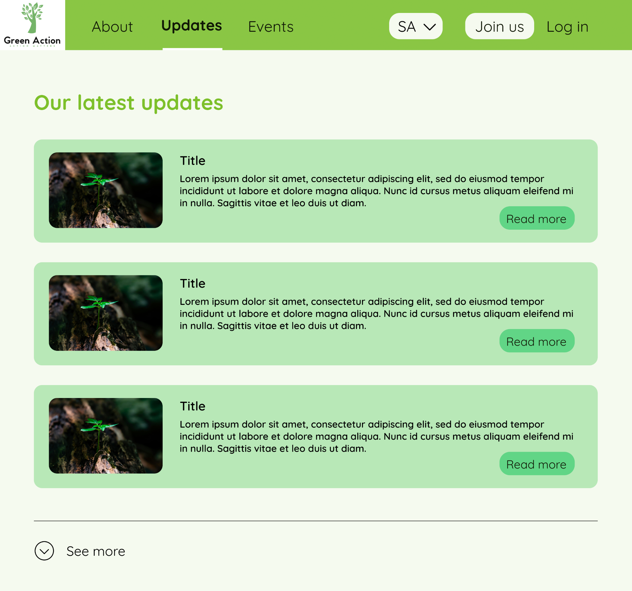

Figure 15 - Guest Updates page

Similar to the Events page, the Updates page provides the latest public updates from the organization, keeping guests informed about recent news and developments. Each update is presented in a card format with a title, brief description, and a "Read more" button that links to a detailed update page.

The page also includes dropdown menus to filter updates by type (e.g., general news, event-related) and sort them by date or relevance. A search function allows users to quickly find specific updates by entering keywords. This structure ensures that guests can easily stay informed about the latest happenings within the organization.

## 2. Users/Volunteers:

This page will be the website for the volunteers. From the requirements, we have decided to have the following sections:

### **Dashboard Page:**

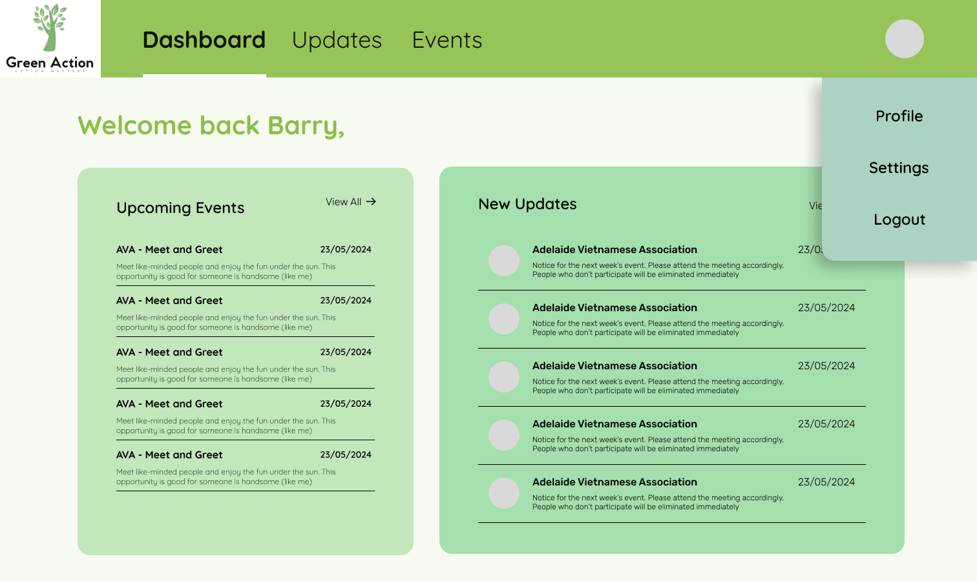

Figure 16 - User Dashboard

The Dashboard page for volunteers is designed to provide the latest updates and events relevant to the user, making it a central hub for essential information. Upon accessing the dashboard, volunteers are greeted with the most recent updates and events from managers. This ensures they are always aware of important information and upcoming activities.

The dashboard also features a navigation bar similar to the homepage, allowing easy access to other sections like the Updates and Events pages. In the upper right corner, users will find their profile icon. Clicking this icon provides options to access Settings, Profile Information, or Logout. The Profile page allows users to edit their personal information, while the Settings page includes options like "Allow email notifications" and "Social Media account link." The Logout option logs the user out of the website.

### **Events Page:**

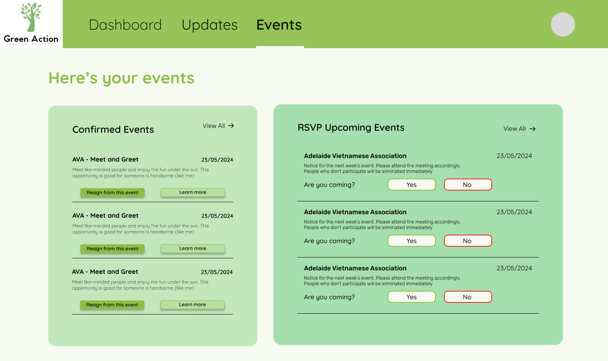

Figure 17 - User Events page

The Events page for volunteers is organized to clearly distinguish between upcoming events and confirmed events. The page is divided into two sections: Upcoming Events to RSVP and Confirmed to Join Events. This layout provides a clear overview of upcoming events, helping users prepare for specific dates.

In the Upcoming Events section, users can see all the organization's upcoming events and choose whether to attend by clicking "Yes" or "No." This interactive feature ensures users can easily manage their participation in events. The Confirmed to Join Events section lists all events the user has already confirmed, allowing them to prepare accordingly. The page’s design is consistent with the dashboard, ensuring a seamless navigation experience.

### **Updates Page:**

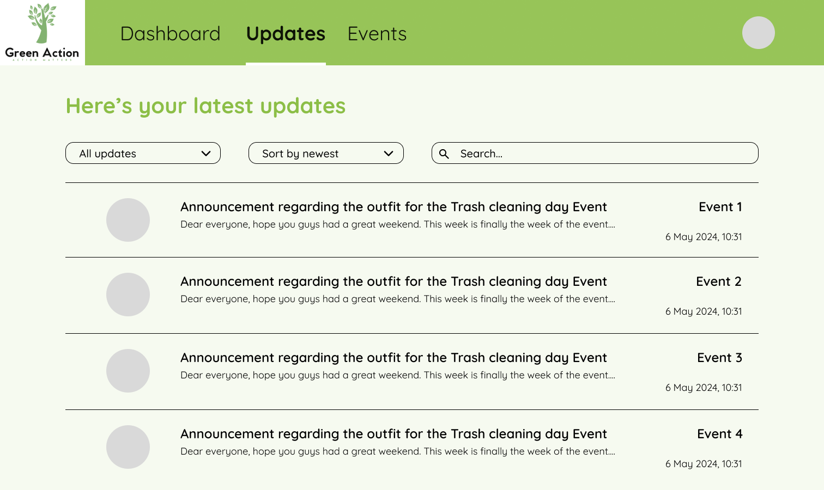

Figure 18 - User Updates page

The Updates page for volunteers is inspired by Myuni’s announcements page. It features a list of the latest announcements from managers, ensuring volunteers are always informed about the latest news. Each announcement includes the manager’s profile picture, the title of the announcement, a description, and the time it was posted. Additionally, it mentions the event associated with the announcement.

To make navigation easier, the page includes filter, sort, and search panels at the top. This allows users to find specific announcements quickly and efficiently. The design is user-friendly and ensures volunteers can stay up-to-date with all the latest information.

## 3. Managers:

This page is the website for the Volunteer Organisation Managers. From the requirements, we have decided to have the following sections:

### **Dashboard Page:**

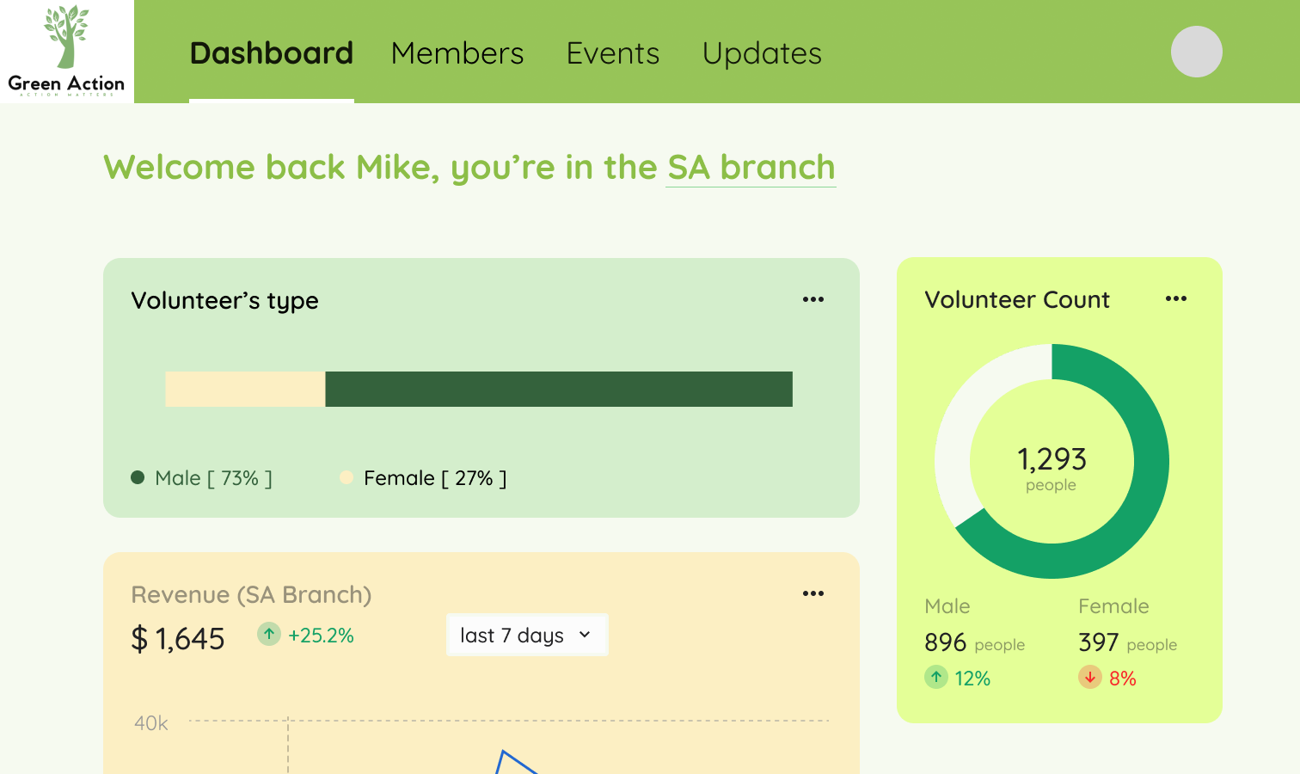

Figure 19 - Manager Dashboard

The Dashboard page for managers serves as a comprehensive overview of essential metrics for efficient management. The top of the page features the organization's logo, name, and a navigation menu with tabs for Dashboard, Members, Events, and Updates. This layout facilitates easy navigation across different sections.

A personalized welcome message greets the manager and specifies their branch. In the upper right corner, a profile picture icon likely opens a dropdown menu with user settings and account management options. The main section of the dashboard includes a horizontal bar chart labeled "Volunteer’s Type," displaying the gender distribution of volunteers, and a donut chart titled "Volunteer Count," showing the total number of volunteers, segmented by gender, with percentage trends indicated.

Another important section is the "Revenue (SA Branch)" display, showing the revenue generated by the SA branch over the last 7 days. A line graph beneath the revenue figure illustrates the trend over time, with a dropdown menu allowing the time frame adjustment. The design uses a calming color scheme of greens and light yellows, with clear typography to emphasize important information. Interactive elements like the profile picture icon and dropdown menus enhance user engagement and usability.

### **Members Page:**

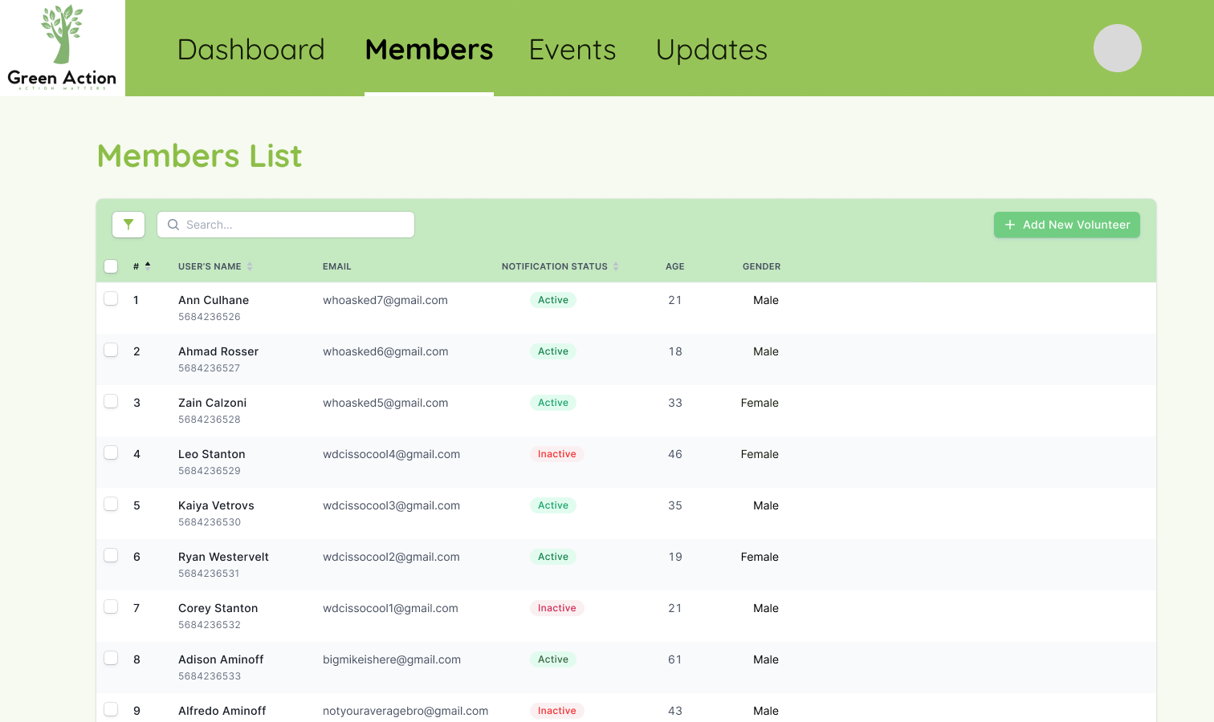

Figure 20 - Manager Members page

The Members page allows managers to manage the list of volunteers in their branch. This page includes a search bar, filter options, and sorting functionality to facilitate easier member management. Managers can quickly locate specific volunteers or filter the list based on certain criteria.

Each volunteer’s details are displayed in a structured table format, including their name, ID number, branch, user type, age, and gender. This organized layout provides a comprehensive view of the volunteers, making it easier for managers to oversee their team. The design is clean and user-friendly, ensuring efficient volunteer management.

### **Updates Page:**

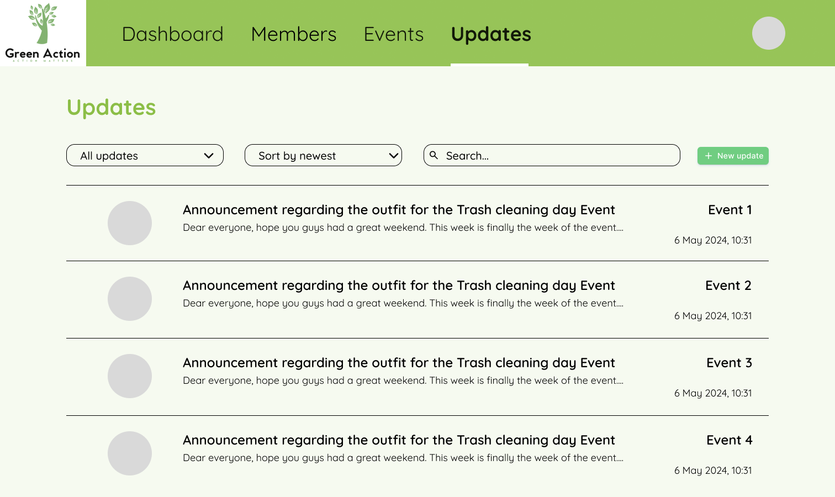

Figure 21 - Manager Updates page

The Updates page for managers allows them to manage all the branch’s latest updates. Managers can view, edit, and post new updates as needed. Each update is displayed with its title, description, and the time it was posted. Managers can also filter and sort updates to find specific posts quickly.

The design is consistent with the overall aesthetic of the dashboard, using the same calming color scheme and clear typography. This ensures that managers can efficiently manage and disseminate information within their branch.

* **Events Page:**

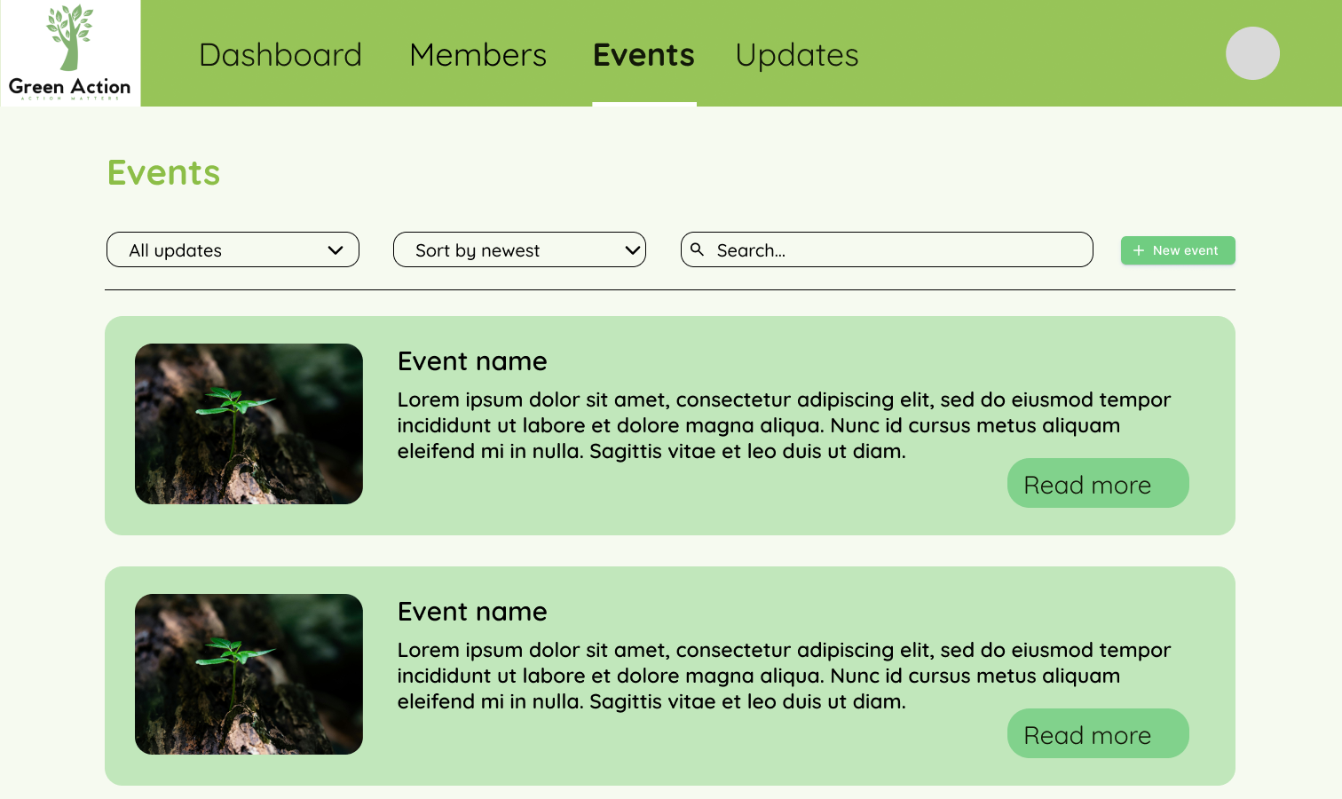

Figure 22 - Manager Events page

The Events page for managers provides an overview of all events associated with the organization. The top of the page features the organization's logo, name, and a navigation menu with tabs for Dashboard, Members, Events, and Updates. The page is dedicated to listing and managing various events.

Interactive elements like a dropdown menu labeled "All updates" allow managers to filter events by different categories or statuses. Another dropdown menu labeled "Sort by newest" enables sorting the events by various criteria such as date, popularity, or relevance. A search bar provides the functionality to quickly find specific events by keywords. To the right of the search bar, a green button labeled "+ New event" allows managers to add new events to the list.

Each event is presented in a card-like format with a visually appealing design. The event cards include an event image, event name, event description, and a "Read more" button that redirects users to a detailed page with more comprehensive information. The design follows a clean and organized aesthetic, consistent with the overall look of the dashboard, ensuring easy navigation and efficient event management.

## 4. Admins:

This page is the website for the Volunteer Organisation Managers. From the requirements, we have decided to have the following sections:

### **Dashboard Page:**

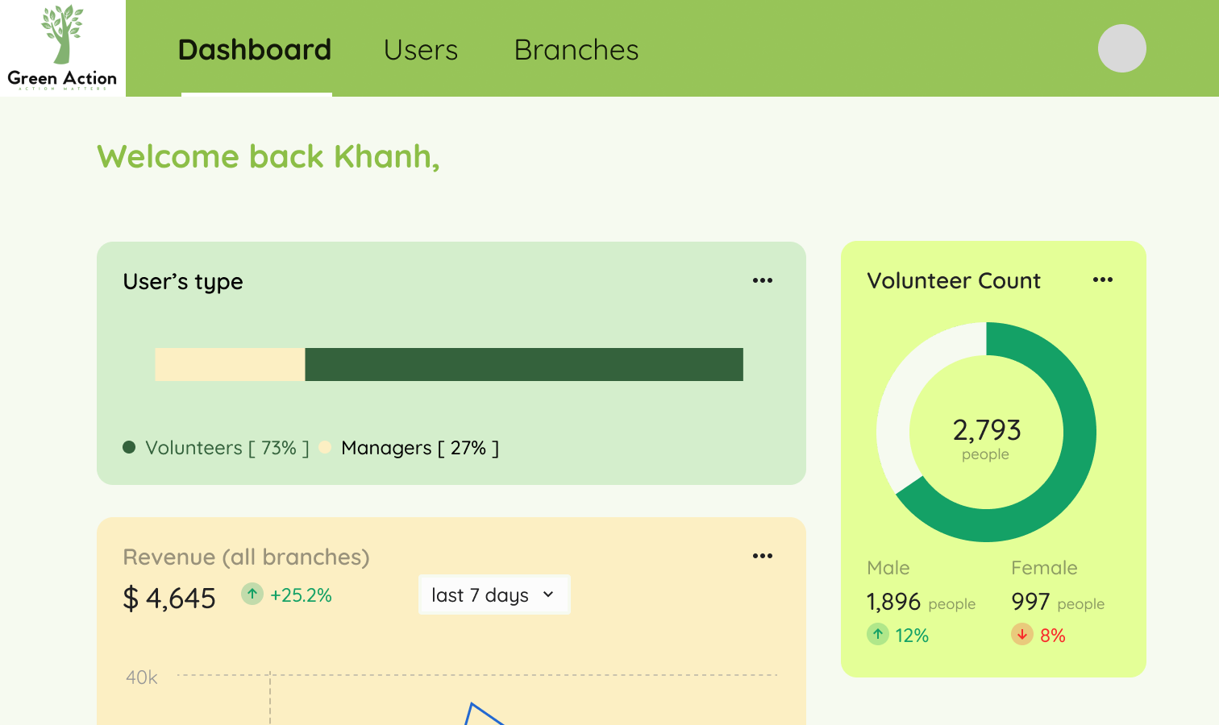

Figure 23 - Admin Dashboard

The Dashboard page for admins provides an overview of the entire organization, including branch management and key metrics. Visual graphs and charts display essential data, making it easier for admins to monitor and manage the organization effectively.

The top of the page features the organization's logo, name, and a navigation menu with tabs for Dashboard, Users, and Branches. This layout facilitates easy navigation across different sections. The design uses a calming color scheme of greens and light yellows, with clear typography to emphasize important information. Interactive elements enhance user engagement and usability, ensuring admins can efficiently oversee the entire organization.

### **Users Page:**

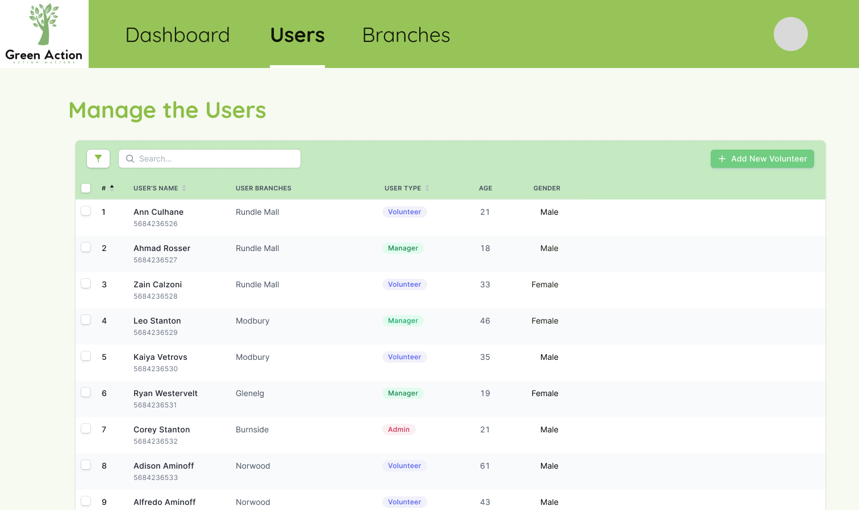

Figure 24 - Admin Users page

The Users page serves as a centralized hub for managers to oversee volunteers across branches. Featuring clear navigation and a structured table layout, managers can easily access volunteer details such as name, branch, user type, age, and gender. Interactive search and filter options streamline management tasks, while an "Add New Volunteer" button facilitates seamless integration of new members. Consistent with the overall design, the page employs a calming color scheme and clear typography for enhanced usability.

### **Branches Page:**

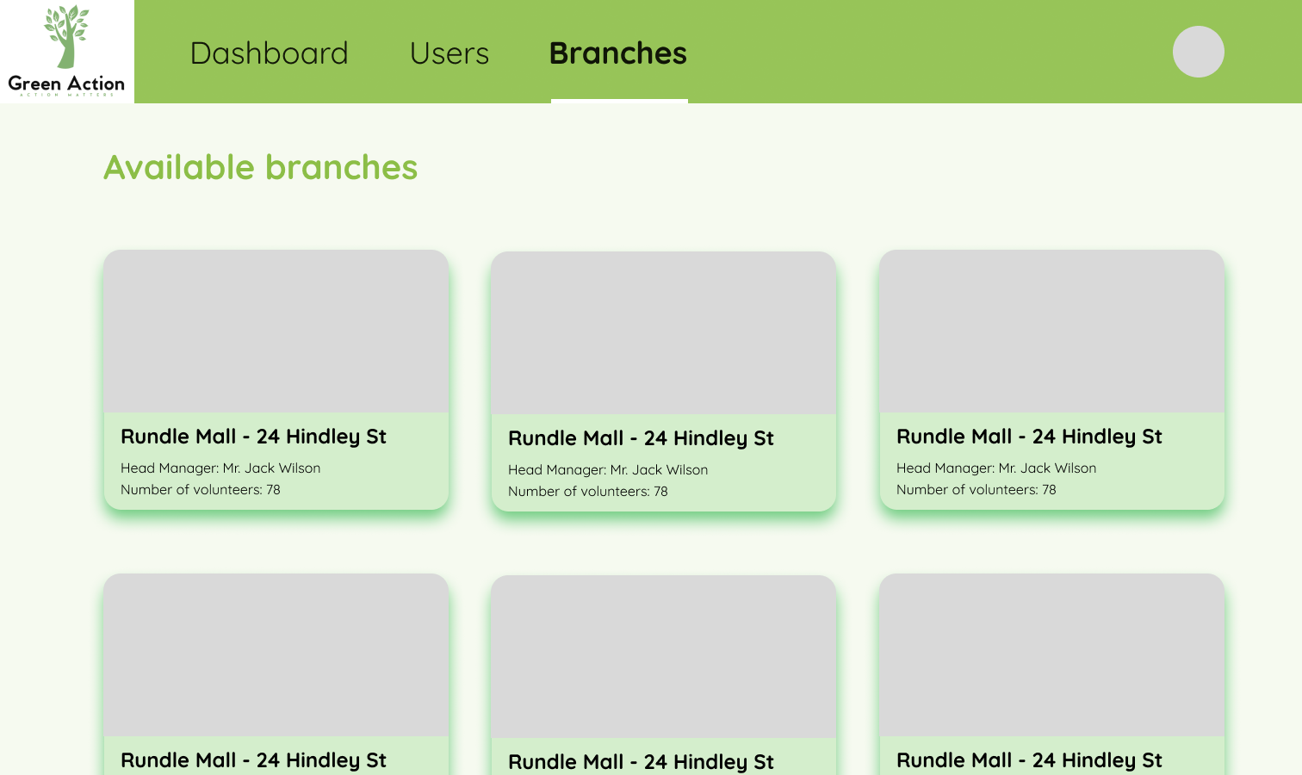

Figure 25 - Admin Branches page

The Branches page empowers administrators with comprehensive control over branch management. Clear navigation and interactive editing tools enable efficient modification of branch details and addition of new branches. Consistency with the platform's design ethos is maintained through a harmonious color scheme and legible typography, ensuring a seamless user experience. Intuitive controls and streamlined functionalities empower administrators to make informed decisions and drive organizational agility effectively.

# III. Review

Reviewing on the design of the webpages, we consider the following aspects of UI/UX design principles to reduce both cognitive and kinematic load when users access and interact with the website:

Feedback received from UG 3 on 05/14/2024 5:49 PM

* Feedback: Design looks great, might be hard to implement.
  + Response: We have simplified the design to promote easier implementation. This is primarily targeted towards the manager and admin homepage and also the admin user management table.
* Feedback: The website is not responsive, doesn’t work well on different screens
  + Response: We are currently trying to use %,vw, and vh instead of px in CSS files, but it still needs improvement.
* Feedback: Data plan looks like it has implemented everything except for the notification sending and receiving features.
  + Response: We have added the notification sending and receiving API design, and included notifications in the database schema.
* Feedback: The is_subscribed attribute seems to be dependent on the user_id (FK), and not on the notification_id (PK). Do you guys want to consider having another table to manage that?
  + Response: We changed the way a user’s subscription state is managed to ensure at least 4NF. This is reflected by a separate table to manage the subscription status of a specific volunteer.
* Feedback: What if the volunteer is a part of multiple branches?
  + Response: We have decided that volunteers will be able to join only one organization corresponding to the region they are in. For example, if they are in Adelaide, they will join the Adelaide branch.

1. Navigation

* We make sure it is easy for users to navigate any buttons or contents on the website. For example, when random users access the homepage (Figure 7), they can immediately see all the events and navigation bars with options like “about”, “updates” and “events” so they will get an idea of what our website is about.
* If existing users want to log in, options for that are right at the top right corner (very simple).

1. Layout

* Contents are organized cleanly in a way that users find information and functionalities linked with each other. In the Volunteer dashboard page (Figure 16), all important options such as “Updates” and “Events” are prioritized on the top left corner while the profile pic is on the other side.This helps reduce steps and time for users to access important information. Any new updates and events are shown next to each other for readability.
* All webpages share the same tone: light with green as the main color. We choose light themes too so that volunteers won’t feel tired with a too colorful webpage and prevent eye tiredness.

1. Typography

* Heading and body are differentiated clearly. Consistent fonts and styles across web pages.
* All options to redirect users to other webpages are on the same line along with profile pic to access personal information. Contents and buttons are centered and side-by-side but separated by different blocks (Figure 17 - Volunteer Updates page).

1. Interactivity

* All buttons representing different functionalities are intelligibly identifiable. In the Manager Members page (Figure 20), “Member” option is highlighted while accessing the page. By highlighting all buttons during interactions, managers may find it easier to perform actions, reducing the use of cognitive resources.
* The cursor changes if managers move the mouse to a particular volunteer’s information line, which indicates that managers can click it to see all information about that volunteer.

1. Performance

* In the designing phase, it is hard to know whether our pages are responsive and fast-loading or not. However, this is what we aim for as it creates a more engaging ,user-friendly and seamless experience. Optimizing images and server response time when users interact with the webpage will help minimize cognitive load.

1. Consistency

* We use the same design thinking across the entire platform to maintain consistency and reduce cognitive load for users as they can predict the UI of different pages and spend less time familiarizing with them (kinematic load). In Manager Updates (Figure 21) and Manager Events pages (Figure 22), the designs for making new events and updates are similar and the same applied for searching up any existing events and updates.